4. Tourism at the Regional Level

Modern tourism has become increasingly competitive, and the development of a new attraction at Gua Petruk (or anywhere else) demands development on a truly competitive level. Here we will summarise several of the key problems, but in following chapters will suggest responses to these problems.

Single isolated attractions are generally not very viable. The path to viability demands either clustering key attractions at a nodal point or establishing a circuit road and trail system that links them together. This means that attractions can develop and operate in a complementary pattern and can be marketed as a group rather than separately. Thus a road and trail circuit in Gombong might include key craft outlets, Jatijajar and Petruk Caves, key craft outlets, selected eating houses and accommodation. A brochure with a map of the circuit and details of each of the selected sites and services should be made readily available

Risk management is also increasingly important within the tourism industry. So, attractions and facilities must be designed and managed in a way that ensures visitor safety. Maintenance must be treated as a matter of high priority with any damage to facilities being repaired as soon as possible and with regular inspections to check for any failures that might otherwise pass un-noticed. It should not be, but is necessary to emphasise that cleanliness of all facilities is vital.

A specific problem in Indonesia is the low level of language skills. Countries that do provide a range of languages at visitor destinations are rapidly cashing in on the international market. This is especially true in the rapidly growing nature-based sector of the industry where interpretation and information services are vital.

The Gombong Plateau as a whole offers attractive and fascinating karstic mountain scenery; Jatijajar offers mass tourism that brings together an Indonesian cultural program within the attractive cave setting; and Gua Petruk would provide an eco-tour experience.

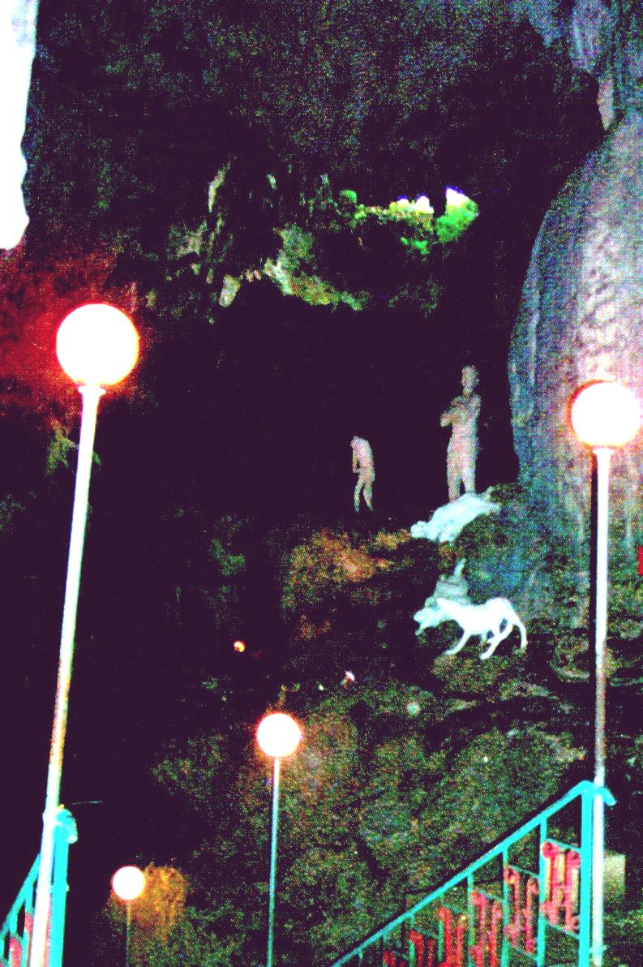  Photograph Otto Soemerwato | Jatijijar is an interesting mass tourism site  with mythical images for amusement, located in an attractive cave and with a large and diverse market to provide by shopping by visitors.

Nature-based Tourism includes:
- Mass Tourism

Adventure Tourism

Hobby Tourism, e.g., bird-watching

Photo Tourism

Ecotourism

There is no question that the future of Gua Petruk depends upon developing an eco- tourism approach, which we will describe in more detail below. Not only is this well suited to the character of the cave, but if we return briefly to the question of regional context, it would mean that an eco-tourism offering at this site would complement rather than compete with other karst tourism opportunities in the region.

5. Ecotourism is . . .

Not just looking at nature, but engaging with it, developing both understanding of nature and a pattern of positive thought, behavior and action towards its care.

It can only be developed with high quality in presentation, delivery of soundly based and inspiring information about a site and its features, and management which enables visitors to engage with what they are visiting.

Engagement is firstly a matter of heightened consciousness and awareness about our personal relationship with nature. One might think, for example, of the poem in which the Vietnamese sage Thich Naht Hahn says I am in the forest and the forest is in me.

Secondly, there is the issue of caring for nature which means

Ensuring that we personally minimise any impacts of our own behavior,

Thus, honoring the environment, with care and carefulness

Expressing care as a value, which I understand might be well expressed by the Japanese term, open, and

Demonstrating carefulness through our actions: nqopèni

So, ecotourism demands a very high level of skill and commitment from guides and other staff. There can be no overall recipe for the skill and creativity which guides must develop but individual guides can and do develop the necessary personal approaches.

The management of such a program must ensure that guides and others do receive appropriate training and staff development. Regular conferences for cave guides, held at different cave sites, and staff exchanges can do a great deal in helping guides to share each other’s experience and expertise. There must also be a career structure so that development in skills and improved work performance is given tangible recognition.

For a number of reasons, I am recommending that the Gua Petruk program should be offered at community level. In particular, it means that visitors can then engage not only with the natural features of the area, but also with the local community. Some input from the district government will doubtless be necessary (e.g., in staff training) but the day-by day responsibility should remain with the community. The key to success in this kind of arrangement is genuine collaborative planning and management.

The total money accrued from visitor fees, sale of food or local crafts or any other services should remain in the local community and as the income grows patterns for fair distribution to staff and others must be worked out. Thus the operation of the cave as a visitor destination will make a very direct contribution to alleviation of poverty in the local area.

